Amenity Survey –
Introduction
We need your help.
The UK government needs to make pragmatic and beneficial decisions for our industry to continue to use pesticides. They need to understand what products are used, how they are used, what are they used for and how much is used. CRD has commissioned the Food and Environment Research Agency to sample the market and obtain this information.
BIGGA promotes best practice and is supportive of FERA obtaining this information. The government has very little if any statistical data to back up its policy decisions. Believe it or not Government has very little data on usage of pesticides in the Amenity sector and no idea how many registered spray operators or sprayers are working in the Amenity sector.
BIGGA along with other organisations representing the Amenity sector have been involved with FERA to put together a survey that should be easy to complete but contain enough information to full fill the objective of this survey.
BIGGA has agreed to promote the survey and ask all members to complete the confidential survey by the end of April 2021, hence this article to help you through completing the survey quickly and accurately.
The survey is designed to be completed online - To access use the link below
https://www.surveymonkey.co.uk/r/AmenitySurvey2020
You and Your Data – confidentiality
All information supplied will be treated in complete confidence and individual participants will not be identified. Your rights regarding any additional data which are processed by FERA in support of the survey can be found here: https://www.fera.co.uk/privacy-policy
Information Needed to Complete the Survey
To be able to complete the survey fully you will only need the following information:
- Number of certificated spray operators employed by your organisation.
- Number of each type of sprayer used by your organisation. (redundant unused equipment in 2020 should be ignored.)
  - Boom sprayers
  - Knapsack sprayers
- List of Products used in calendar year 2020.
  - Name of product.
  - Quantity used in calendar year 2020 (total l/kg)
  - Purpose product used for.
To help you obtain this information and make completing the survey as easy as possible we have put together a simple guide.

How to Guide
First page: complete regarding the organisation you represent – is self- explanatory. 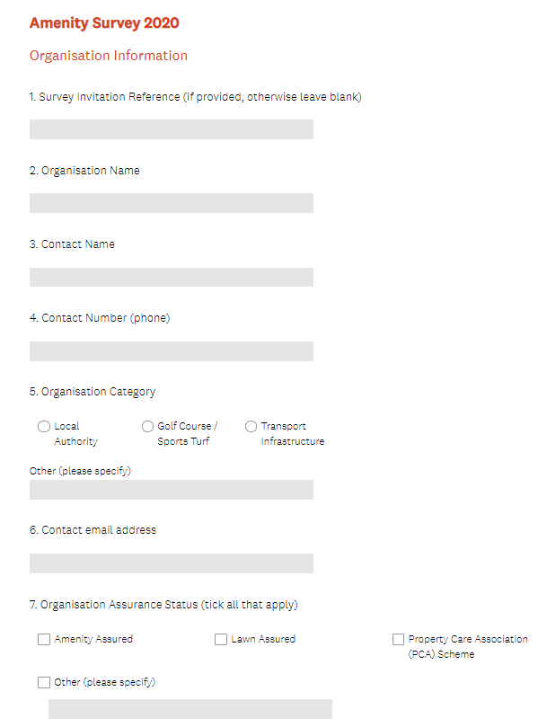

Page 2 –
Question 8: enter number of Grounds staff employed on site. Questions 9 & 10 self-explanatory
Question 11: Enter number of units of application equipment used on site in each category.
To simplify this just include: Number of Knapsacks Sprayer, Number of motorised Sprayers use don site, Number of Stem injectors, number of CDA units
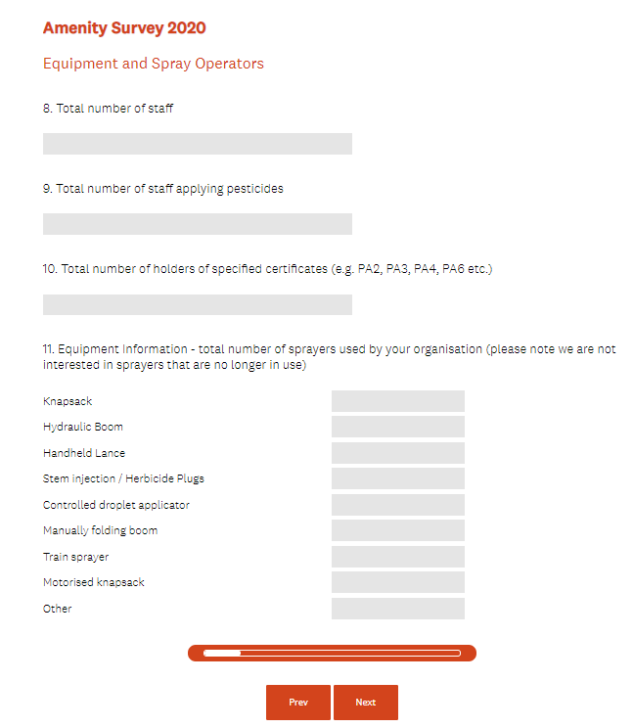

The survey is looking to obtain information on the quantity of Pesticides used in the Amenity sector. This information should be available from you spray record book. Pesticides for this survey are defined as products which are registered by HSE / CRD that have a MAPP number.
The survey can collect usage of up to 8 individual products for users of a larger number of products the usage information needs to be supplied electronically – to help members with this requirement we have put together a spreadsheet you can complete for usage by product in 2020 see below
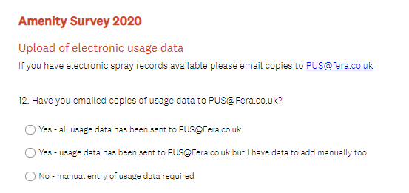
This section allows you to confirm if you intend to send product usage information from a report generated by computerised record keeping software. The report needs to list Product name – litres of product used – crop or surface applied e.g. Greens, Tees etc and purpose of use e.g. general weed control. The easiest method to return this information if you use a large number of products is to download and complete the spreadsheet from the BIGGA website - link http//cvcbvxxx?. Note on how to complete are included on this spreadsheet. The sheet can be completed, and then emailed to FERA at PUS@fera.co.uk.
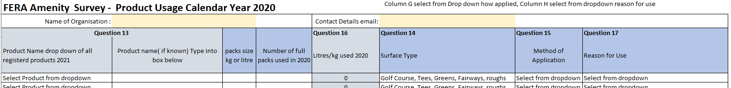

If this method is being used tick relevant box above and send attachment of the Excel sheet.
The 3rd option if you use only a small number of plant protection products (PPP) is to complete up to 8 product sheets on the online survey.

Question 13
Enter product name in box.
Question 14
For most products - Tick boxes of surfaces applied for most organisations just tick Golf Course
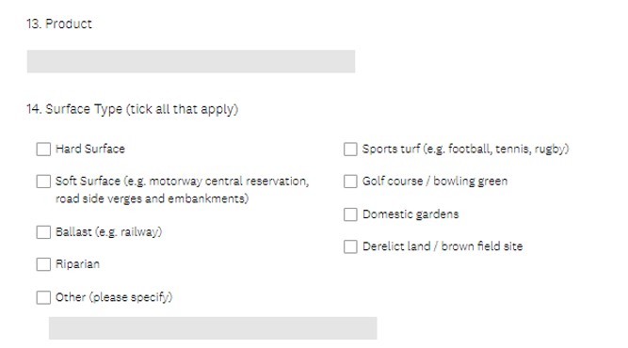
Question 15
Method of Application. -Tick how the product was applied methods used for this product tick either boom sprayer or handheld sprayer
Question 16
Calculate litres of the names product used in calendar year 2020.
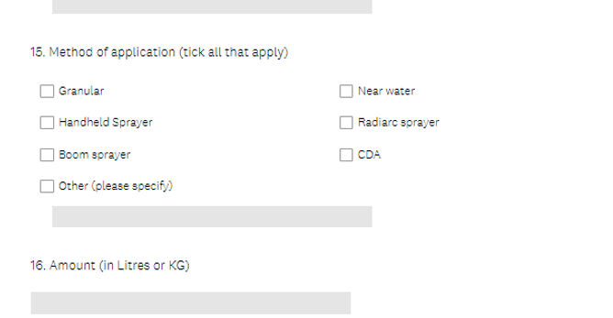

Question 17
Tick reasons for use of this product – for Fungicides if disease is not known - tick Microdochium/fusarium patch

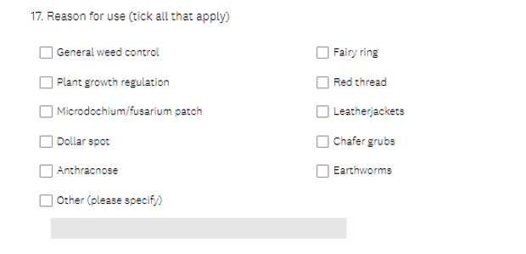
Click – next
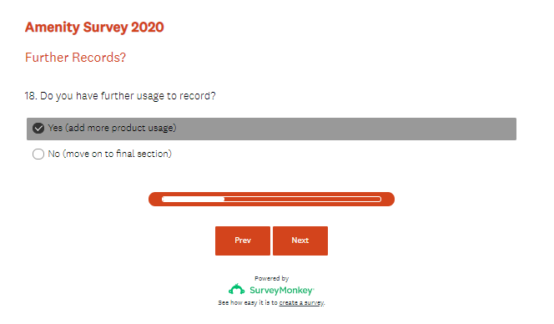
If Yes selected, this takes you back to complete next product – this can be done up to a maximum of 8 times. Most clubs will use more than 8 registered PPP products so it is easier and quicker to use the spreadsheet prepared for BIGGA which is available on WWW. etc

If no selected will go through to last screen
